Seventeenth Sunday after Pentecost
10:00
October 2, 2022
Zion Lutheran Church Camas, Washington
Ministers: the entire congregation
Christopher Hogstad, Senior Pastor
Pam Ensley, Youth Minister
Patricia Hagensen, Administrative Assistant
Church office 360-834-4201
email info@zionluthcamas.org
Hours: Mon 8-12:00, Tues-Fri 8-5:00
“As a welcoming Body of Christ, we celebrate and share God’s saving grace for all.”

We welcome all who worship with us. Because we enjoy knowing
who is with us on Sunday mornings we ask that you sign your name,
address, etc. on the Friendship Pads as they are being distributed.
Please note the names of those sitting around you and following the
service introduce yourselves.
Holy Communion: All are invited to share in Holy Communion. Wine is
served, but grape juice is available. To receive grape juice simply lift
your index finger when the communion assistant stands before you.
Gluten-free wafers are available – please ask. Children are invited
forward with their families to receive either communion or a blessing.
After receiving the bread and wine you may return to your seat using
the side aisles. If you commune, please check the appropriate box in
the Friendship Pad that your communion may be recorded.
Children are invited and strongly encouraged to attend worship.
Children’s packets are available and can be picked up from the ushers.
Please return children’s packets following the service.
Refreshments are served in the Social Hall following the service.
Check the Zion Weekly (blue insert) for the calendar and upcoming
activities. You are invited to participate in these ministries or any
other program we offer during the week.
INTRODUCTION
A little faith goes a long way is Jesus’ point in the gospel. A mustard
seed’s-worth of faith has miraculous potential. The patience, tenacity,
and endurance required for the life of faith are the blessings received
in holy baptism, holy communion, and the word read and proclaimed
in this assembly. Anticipate them. Receive them with thanksgiving.
Prelude Bella Tolentino
Welcome and Announcements
GATHERING
Stand – if standing is difficult please feel free to remain seated
P: Blessed be the holy Trinity, ☩ one God, who is eager to
forgive and who loves us beyond our days. Amen.
P: Dear friends, together let us acknowledge our failure to love
this world as Jesus does.
Silence is kept for reflection
P: God of mercy and forgiveness,
C: we confess that sin still has a hold on us. We have harmed
your good creation. We have failed to do justice, love
kindness, and walk humbly with you. Turn us in a new
direction. Show us the path that leads to life. Be our refuge
and strength on the journey, through Jesus Christ, our
redeemer and friend. Amen.
P: Beloved of God: your sins are forgiven ☩ and you are made
whole. God points the way to new life in Christ, who meets us
on the road. Journey now in God’s abiding love through the
power of the Holy Spirit. Amen.
Opening Hymn “All Creatures, Worship God Most High!”
v. 1, 2, 4, 6 Number 835
1 All creatures, worship God most high! Sound ev'ry voice in earth
and sky: Alleluia! Alleluia! Sing, brother sun, in splendor bright;
sing, sister moon and stars of night: Alleluia, alleluia, alleluia,
alleluia, alleluia!
2 Sing, brother wind; with clouds and rain you grow the gifts of fruit
and grain: Alleluia! Alleluia! Dear sister water, useful, clear, make
music for your Lord to hear: Alleluia, alleluia, alleluia, alleluia,
alleluia!
-2-
4 All who for love of God forgive, all who in pain and sorrow grieve:
Alleluia! Alleluia! Christ bears your burdens and your fears; still
make your song amid the tears: Alleluia, alleluia, alleluia, alleluia,
alleluia!
6 O sisters, brothers, take your part, and worship God with humble
heart: Alleluia! Alleluia! All creatures, bless the Father, Son, and
Holy Spirit, Three in One: Alleluia, alleluia, alleluia, alleluia, alleluia!

Greeting
L: The grace of our Lord Jesus Christ, the love of God, and the
communion of the Holy Spirit be with you all.
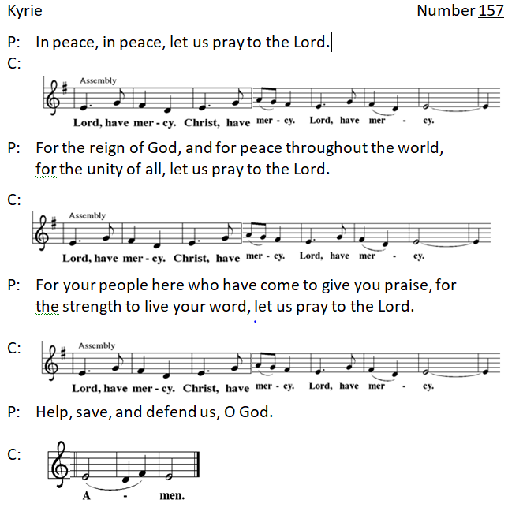
And also with you.
“Now the Feast and Celebration” Number 167

P: The Lord be with you. And also with you.
-4-
P: Let us pray. Benevolent, merciful God:
C: When we are empty, fill us. When we are weak in faith,
strengthen us. When we are cold in love, warm us, that with
fervor we may love our neighbors and serve them for the
sake of your Son, Jesus Christ, our Savior and Lord. Amen.
WORD

Bible Reading Habakkuk 1:1-4; 2:1-4
The oracle that the prophet Habakkuk saw. ²O Lord, how long shall I cry for help, and you will not listen? Or cry to you “Violence!” and you will not save? ³Why do you make me see wrongdoing and look at trouble? Destruction and violence are before me; strife and
contention arise. ⁴So the law becomes slack and justice never prevails. The wicked surround the righteous—therefore judgment comes forth perverted. ^{2:1}I will stand at my watchpost, and station myself on the rampart; I will keep watch to see what he will say to me, and what he will answer concerning my complaint. ²Then the Lord answered me and said: Write the vision; make it plain on tablets, so that a runner may read it. ³For there is still a vision for the appointed time; it speaks of the end, and does not lie. If it seems to tarry, wait for it; it will surely come, it will not delay. ⁴Look at the proud! Their spirit is not right in them, but the righteous live by their faith.

L: Word of God, word of life.
C: Thanks be to God.
Responsive Reading Psalm 37:1-9
L: Do not be provoked by evildoers; do not be jealous of those who
do wrong.
C: For they shall soon wither like the grass, and like the green
grass fade away.
L: Put your trust in the Lord and do good; dwell in the land and find
safe pasture.
C: Take delight in the Lord, who shall give you your heart’s desire.
L: Commit your way to the Lord; put your trust in the Lord, and see
what God will do.

C: The Lord will make your vindication as clear as the light and the
justice of your case like the noonday sun.
L: Be still before the Lord and wait patiently. Do not be provoked by
the one who prospers, the one who succeeds in evil schemes.
C: Refrain from anger, leave rage alone; do not be provoked; it
leads only to evil.
L: For evildoers shall be cut off,
C: but those who hope in the Lord shall possess the land.

Bible Reading 2 Timothy 1:1-14
Paul, an apostle of Christ Jesus by the will of God, for the sake of the promise of life that is in Christ Jesus, ²To Timothy, my beloved child: Grace, mercy, and peace from God the Father and Christ Jesus our Lord. ³I am grateful to God—whom I worship with a clear conscience, as my ancestors did—when I remember you constantly in my prayers night and day. ⁴Recalling your tears, I long to see you so that I may be filled with joy. ⁵I am reminded of your sincere faith, a faith that lived first in your grandmother Lois and your mother Eunice and now, I am sure, lives in you. ⁶For this reason I remind you to rekindle the gift of God that is within you through the laying on of my hands; ⁷for God did not give us a spirit of cowardice, but rather a spirit of power and of love and of self-discipline. ⁸Do not be ashamed, then, of the testimony about our Lord or of me his prisoner, but join with me in suffering for the gospel, relying on the power of God, ⁹who saved us and called us with a holy calling, not according to our works but according to his own purpose and grace. This grace was given to us in Christ Jesus before the ages began, ¹⁰but it has now been revealed through the appearing of our Savior Christ Jesus, who abolished death and brought life and immortality to light through the gospel. ¹¹For this gospel I was appointed a herald and an apostle and a teacher, ¹²and for this reason I suffer as I do. But I am not ashamed, for I know the one in whom I have put my trust, and I am sure that he is able to guard until that day what I have entrusted to him. ¹³Hold to the standard of sound teaching that you have heard from me, in the faith and love that are in Christ Jesus. ¹⁴Guard the good treasure entrusted to you, with the help of the Holy Spirit living in us.

L: Word of God, word of life. C: Thanks be to God.
-6-
Stand
Gospel Acclamation Page 151
P: The Holy Gospel according to St. Luke, the seventeenth chapter.
C: Glory to you, O Lord.

Gospel Reading Luke 17:5-10
The apostles said to the Lord, “Increase our faith!” ⁶The Lord replied, “If you had faith the size of a mustard seed, you could say to this mulberry tree, ‘Be uprooted and planted in the sea,’ and it would obey you. ⁷“Who among you would say to your slave who has just come in from plowing or tending sheep in the field, ‘Come here at once and take your place at the table’? ⁸Would you not rather say to him, ‘Prepare supper for me, put on your apron and serve me while I eat and drink; later you may eat and drink’? ⁹Do you thank the slave for doing what was commanded? ¹⁰So you also, when you have done all that you were ordered to do, say, ‘We are worthless slaves; we have done only what we ought to have done!’ ”

P: The Gospel of the Lord. Praise to you, O Christ!
Sit
Children’s Message Pam Ensley
Message Pr. Chris Hogstad
Stand
Hymn of the Day “Holy Spirit, Truth Divine” v. 1-3 Number 398
1 Holy Spirit, truth divine, dawn upon this soul of mine;
breath of God and inward light, wake my spirit, clear my sight.
2 Holy Spirit, love divine, glow within this heart of mine;
kindle ev'ry high desire; purge me with your holy fire.
3 Holy Spirit, pow'r divine, fortify this will of mine;
by your will I strongly live, bravely bear, and nobly strive.
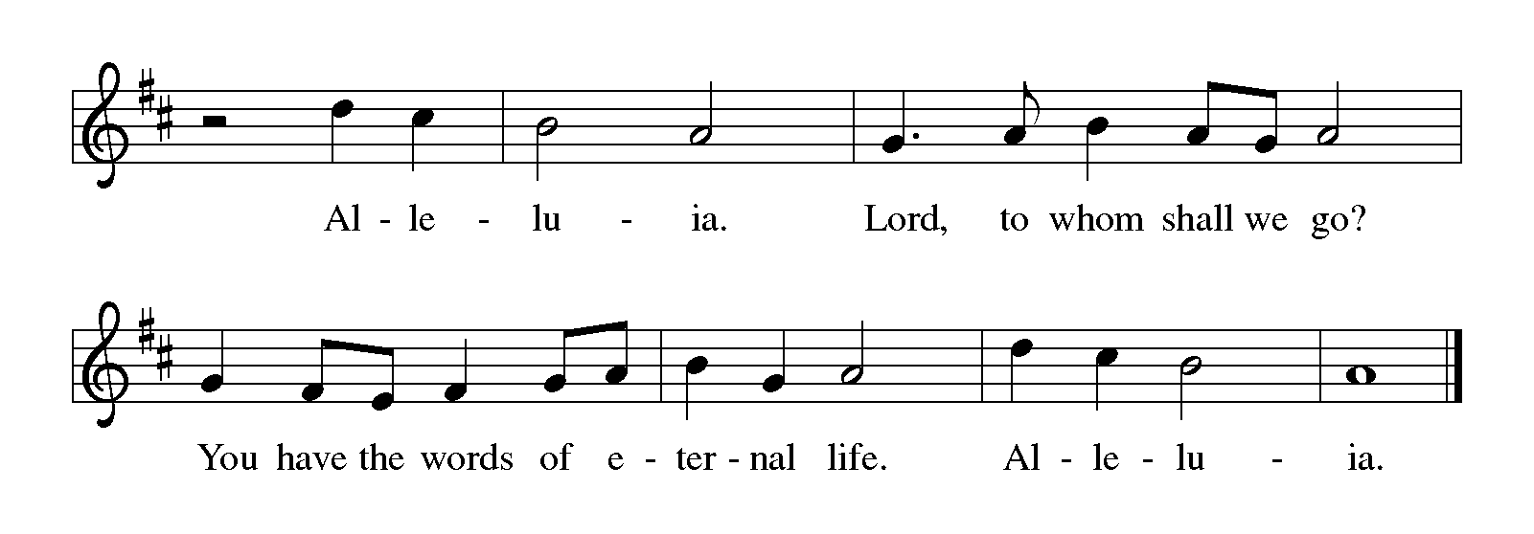Presentation of New Members
Dear friends, we give thanks for the gift of baptism and for Jerry &
Carolyn, Duane & Sherry, Jolene, Bryce and Jane, and Jolene, one
with us in the body of Christ, whom we welcome as new members
into the life and ministry of this congregation.
Apostles’ Creed
I believe in God, the Father almighty, creator of heaven and
earth.
I believe in Jesus Christ, God’s only Son, our Lord, who was
conceived by the Holy Spirit, born of the virgin Mary, suffered
under Pontius Pilate, was crucified, died, and was buried; he
descended to the dead. On the third day he rose again; he
ascended into heaven, he is seated at the right hand of the
Father, and he will come to judge the living and the dead.
I believe in the Holy Spirit, the holy catholic church, the
communion of saints, the forgiveness of sins, the resurrection of
the body, and the life everlasting. Amen.
Address and Questions
P: In baptism, we are welcomed into the body of Christ and sent to
share in the mission of God. We are called to live among God’s
faithful people, to hear the word of God and share in the Lord’s
supper, to proclaim the good news of God in Christ through word
and deed, to serve all people, following the example of Jesus, and
to strive for justice and peace in all the earth.
Sisters and brothers in Christ, do you intend to continue in the
covenant of your baptism among God’s people in this place?
NM: I do, and I ask God to help and guide me.
People of God, do you promise to support and pray for these new
members in their life in Christ?
C: We do, and we ask God to help and guide us.
-8-
P: Let us welcome these sisters and brothers in Christ to this
community of faith.
C: We rejoice with you in the life of baptism. Together we will give
thanks and praise to God and proclaim the good news to all the
world.
P: We give you thanks for our new members whom you have drawn
to yourself by the love of Jesus Christ and whom we have
welcomed into this household of faith. Keep us close together
in your Spirit, in the breaking of bread and the prayers, and in
service to others.
The Prayers
As scattered grains of wheat are gathered together into one bread, so let us gather our prayers for the church, those in need, and all of God’s good creation.
A brief silence
We pray for your holy church in every place and for those who serve
following the example of Christ. Help them to live by faith and walk by
the light of your gospel. God of grace, hear our prayer.
For parts of the world ravaged by natural disaster: relieve those
affected by floods, wildfires, droughts, earthquakes, tornadoes, and
hurricanes. God of grace, hear our prayer.
For every nation and for those entrusted with authority: grant our
leaders self-discipline in all things, and inspire them with love for your
people. God of grace, hear our prayer.
For victims of violence, abuse, and neglect: heal those who have been
harmed and protect those who are vulnerable. For all who are sick,
especially those we remember aloud or in our hearts. God of grace,
hear our prayer.
For this and every congregation: rekindle your gifts within your
people, and inspire councils, committees, and individuals to plan and
work together that all may know your love. God of grace, hear our
prayer.

In thanksgiving that you have abolished death, and for the saints who
have died. Bring us all to eternal life with you. God of grace, hear our
prayer.
Gathered together in the sweet communion of the Holy Spirit,
gracious God, we offer these and all our prayers to you; through Jesus
Christ, our Savior. Amen.
Peace
P: The peace of the Risen Christ be with you always. And also with
you.
Offering of Tithes and Gifts
Offertory
Prayer of Preparation
P: Gracious God, in your great love you richly provide for our
needs. Make of these gifts a banquet of blessing, and make
us ready to share with all in need; through Jesus Christ, who
sets a table for all. Amen.
MEAL
Holy, Holy, Holy Page 191

-10-
Eucharistic Prayer
The Lord’s Prayer
Our Father, who art in heaven, hallowed be thy name, thy kingdom
come, thy will be done, on earth as it is in heaven. Give us this day
our daily bread; and forgive us our trespasses, as we forgive those
who trespass against us; and lead us not into temptation, but deliver
us from evil. For thine is the kingdom, and the power, and the glory,
forever and ever. Amen.
Invitation to Communion
Christ invites you to this table. Come, taste and see.
Distribution Hymns
“Lord, Enthroned in Heavenly Splendor” Number 475
1. Lord, enthroned in heav’nly splendor, first begotten from the
dead, you alone, our strong defender, lifting up your people’s
head. Alleluia, alleluia, alleluia, alleluia! Jesus, true and living
bread! Jesus, true and living bread!
2. Though the lowliest form now veil you as of old in Bethlehem,
here as there your angels hail you, branch and flow’r of
Jesse’s stem. Alleluia, alleluia, alleluia, alleluia! We in worship
join with them; we in worship join with them.
3. Paschal Lamb, your off’ring, finished once for all when you
were slain, in its fullness undiminished shall forevermore
remain. Alleluia, alleluia, alleluia, alleluia! Cleansing souls
from ev’ry stain; cleansing souls from ev’ry stain.
4. Life imparting heav’nly manna, stricken rock with streaming
side, heav’n and earth with loud hosanna worship you the
Lamb who died, Alleluia, alleluia, alleluia, alleluia! Ris’n,
ascended, glorified; ris’n, ascended, glorified!
“What Wondrous Love Is This” Number 666
1. What wondrous love is this, O my soul, O my soul! What
wondrous love is this, O my soul! What wondrous love is this
that caused the Lord of bliss to bear the dreadful curse for my
soul, for my soul, to bear the dreadful curse for my soul?

2. When I was sinking down, sinking down, sinking down, when I
was sinking down, sinking down, when I was sinking down
beneath God’s righteous frown, Christ laid aside his crown for
my soul, for my soul, Christ laid aside his crown for my soul.
3. To God and to the Lamb I will sing, I will sing, to God and to
the Lamb I will sing; to God and to the Lamb, who is the great
I AM, while millions join the theme, I will sing, I will sing, while
millions join the theme, I will sing.
4. And when from death I’m free, I’ll sing on, I’ll sing on; and
when from death I’m free, I’ll sing on; and when from death
I’m free, I’ll sing God’s love for me, and through eternity I’ll
sing on, I’ll sing on; and through eternity I’ll sing on.
Blessing
P: May the grace of our Lord Jesus Christ and the gifts of his body
and blood strengthen, keep and unite us both now and forever.
Amen.
Prayer after Communion
P: God of the abundant table, you have refreshed our hearts in
this meal with bread for the journey. Give us your grace on
the road that we might serve our neighbors with joy; for the
sake of Jesus Christ, our Lord. Amen.

Benediction
P: God, who gives life to all things and frees us from despair,
bless you with truth and peace. And may the holy
Trinity, ☩ one God, guide you always in faith, hope, and
love. Amen.
Sending Hymn “Son of God, Eternal Savior” v. 1-3 Number 655
1. Son of God, eternal Savior, source of life and truth and grace, Word made flesh, whose birth among us hallows all our human
race, you our head, who, throned in glory, for your own will ever
plead: fill us with your love and pity, heal our wrongs, and help
our need.

-12-
2 As you, Lord, have lived for others, so may we for others live. Freely have your gifts been granted; freely may your servants
give. Yours the gold and yours the silver, yours the wealth of
land and sea; we but stewards of your bounty held in solemn
trust will be.
3 Come, O Christ, and reign among us, King of love and Prince of
peace; hush the storm of strife and passion, bid its cruel
discords cease. By your patient years of toiling, by your silent
hours of pain, quench our fevered thirst of pleasure, stem our
selfish greed of gain.

Dismissal

L: Go in peace. Love your neighbor. Thanks be to God!
Postlude

Today’s Flowers – Ursula Richards
To the Glory of God and in memory of my mother, Margarete Ehrlich

Coffee Hour – Hogstad Family

SERVICE
Usher Norm Bembenek
Greeter Ursula Richards
Lector Nancy Vargo
Sound Tech Max Malcom
Digital Media Coordinator Angelyka Cava
Musicians Pat Hagensen, Judy Swanson, Bella Tolentino
Lay Assistant, Basket Assistant LaDene Mattson, Karen Blair
Altar Guild Marilyn Anderson, Florence Faraone, Barbara West

Liturgy used with permission under license from Augsburg Fortress through Sundays and Seasons, #SAS006227. Text, Music, and Streaming - One License #A-706949; CCLI #791428

“All Creatures, Worship God Most High!”
Text: Francis of Assisi, tr. Composite
Music: LASST UNS ERFREUEN, Geistliche Kirchengesänge, Köln
Text: @1997 Augsburg Fortress
“Holy Spirit, Truth Divine”
Text: Samuel Longfellow
Music: SONG 13, Orlando Gibbons

“Lord, Enthroned in Heavenly Splendor”
Text: George H. Bourne
Music: BRYN CALFARIA, William Owen

“What Wondrous Love Is This”
Text: North American folk hymn
Music: WONDROUS LOVE, W. Walker, Southern Harmony,
arr. Paul J. Christiansen
Arr. @1955 Augsburg Fortress Publishing House, admin. Augsburg Fortress

“Son of God, Eternal Savior”
Text: Somerset C. Lowry
Music: IN BABILONE, Oude en Nieuwe Hollantse Boerenlities en Contradansen

