Fourth Sunday after Epiphany
10:00
January 29, 2023
Zion Lutheran Church Camas, Washington
Ministers: the entire congregation
Rev. Christopher Hogstad
Pam Ensley, Youth Minister
Patricia Hagensen, Administrative Assistant
Church office 360-834-4201
email info@zionluthcamas.org
Hours: Mon 8-12:00, Tues-Fri 8-5:00
“As a welcoming Body of Christ, we celebrate and share God’s saving grace for all.”

We welcome all who worship with us. Because we enjoy knowing
who is with us on Sunday mornings we ask that you sign your name,
address, etc. on the Friendship Pads as they are being distributed.
Please note the names of those sitting around you and following the
service introduce yourselves.
Holy Communion: All are invited to share in Holy Communion. Wine is
served, but grape juice is available. To receive grape juice simply lift
your index finger when the communion assistant stands before you.
Gluten-free wafers are available – please ask. Children are invited
forward with their families to receive either communion or a blessing.
After receiving the bread and wine you may return to your seat using
the side aisles. If you commune, please check the appropriate box in
the Friendship Pad that your communion may be recorded.
Children are invited and strongly encouraged to attend worship.
Children’s packets are available and can be picked up from the ushers.
Please return children’s packets following the service.
Refreshments are served in the Social Hall following the service.
Check the Zion Weekly (blue insert) for the calendar and upcoming
activities. You are invited to participate in these ministries or any
other program we offer during the week.
INTRODUCTION
Who are the blessed ones of God? For Micah, they are those who do
justice, love kindness, and walk humbly with God. For Paul, they are
the ones who find wisdom in the weakness of the cross. For Jesus,
they are the poor, the meek, the merciful, the pure in heart, the
peacemakers, those who mourn, and those who hunger for
righteousness. In baptism we find our blessed identity and calling in
this countercultural way of living and serving.

Prelude Gary Ritter
Welcome and Announcements
GATHERING
Stand – if standing is difficult please feel free to remain seated

Confession and Forgiveness
P: Blessed be the holy Trinity, ☩ one God, who makes all things
new, whose mercy endures forever. Amen.
P: Trusting in God’s mercy, let us confess our sin.
Silence is kept for reflection
P: Holy One, source of our renewal,
C: we confess that we are wrapped up in sin, and cannot free
ourselves. We have not practiced your righteousness. Our
hearts have turned away from you. For the sake of the world
you so love, forgive us, that we may be reconciled to one
another for the glory of your holy name. Amen.
P: Thus says our God: “The former things have come to pass and
new things I now declare.” God’s mercy makes us new. We
are forgiven in the name of ☩ Christ our Savior. Amen.
Opening Hymn “Gather Us In” Number 532
1. Here in this place the new light is streaming, now is the
darkness vanished away; see in this space our fears and our
dreamings brought here to you in the light of this day. Gather
us in, the lost and forsaken, gather us in, the blind and the
lame; call to us now, and we shall awaken, we shall arise at
the sound of our name.

-2-

2. We are the young, our lives are a myst’ry, we are the old who
yearn for your face; we have been sung throughout all of hist’ry,
called to be light to the whole human race. Gather us in, the rich
and the haughty, gather us in, the proud and the strong; give us
a heart, so meek and so lowly, give us the courage to enter the
song.
3. Here we will take the wine and the water, here we will take the
bread of new birth, here you shall call your sons and your
daughters, call us anew to be salt for the earth. Give us to drink
the wine of compassion, give us to eat the bread that is you;
nourish us well, and teach us to fashion lives that are holy and
hearts that are true.
4. Not in the dark of buildings confining, not in some heaven, light
years away – but here in this place the new light is shining, now
is the kingdom, and now is the day. Gather us in and hold us
forever, gather us in and make us your own, gather us in, all
peoples together, fire of love in our flesh and our bone.
Greeting
P: The grace of our Lord Jesus Christ, the love of God, and the
communion of the Holy Spirit be with you all. And also with you.
Kyrie Page 147
A: In peace, let us pray to the Lord.
C:

A: For the peace from above, and for our salvation, let us pray to
the Lord.

A: For the peace of the whole world, for the well-being of the
church of God, and for the unity of all, let us pray to the Lord.

A: For this holy house, and for all who offer here their worship and
praise, let us pray to the Lord.

A: Help, save, comfort, and defend us, gracious Lord.
C:

Hymn of Praise Page 149-150
A: This is the feast of victory for our God. Alleluia.
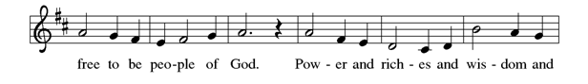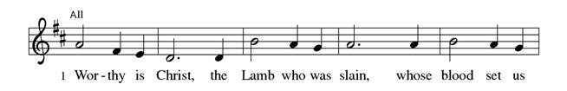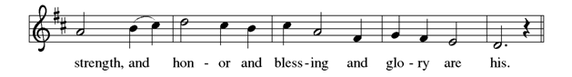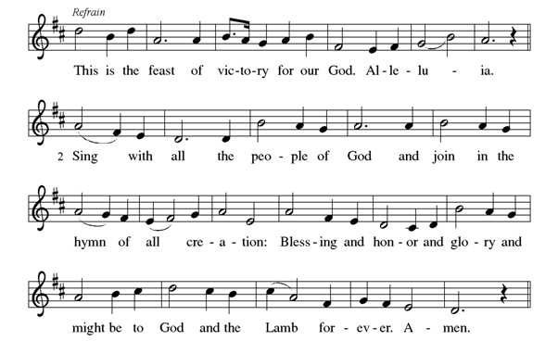

-4-
P: The Lord be with you. And also with you.
P: Let us pray. Holy God,
C: you confound the world’s wisdom in giving your kingdom to
the lowly and the pure in heart. Give us such a hunger and
thirst for justice, and perseverance in striving for peace, that
in our words and deeds the world may see the life of your
Son, Jesus Christ, our Savior and Lord. Amen.
WORD

First Reading Micah 6:1-8
Hear what the Lord says: Rise, plead your case before the mountains, and let the hills hear your voice. ²Hear, you mountains, the controversy of the Lord, and you enduring foundations of the earth; for the Lord has a controversy with his people, and he will contend with Israel. ³“O my people, what have I done to you? In what have I wearied you? Answer me! ⁴For I brought you up from the land of Egypt, and redeemed you from the house of slavery; and I sent before you Moses, Aaron, and Miriam. O my people, remember now what King Balak of Moab devised, what Balaam son of Beor answered him, and what happened from Shittim to Gilgal, that you may know the saving acts of the Lord.” ⁶“With what shall I come before the Lord, and bow myself before God on high? Shall I come before him with burnt offerings, with calves a year old? ⁷Will the Lord be pleased with thousands of rams, with ten thousands of rivers of oil? Shall I give my firstborn for my transgression, the fruit of my body for the sin of my soul?” ⁸He has told you, O mortal, what is good; and what does the Lord require of you but to do justice, and to love kindness, and to walk humbly with your God?

L: Word of God, Word of life.
C: Thanks be to God.

Responsive Reading Psalm 15
L: Lord, who may dwell in your tabernacle? Who may abide
upon your holy hill?
C: Those who lead a blameless life and do what is right, who
speak the truth from their heart;
L: they do not slander with the tongue, they do no evil to their
friends; they do not cast discredit upon a neighbor.
C: In their sight the wicked are rejected, but they honor those
who fear the Lord. They have sworn upon their health and do
not take back their word.
L: They do not give their money in hope of gain, nor do they
take bribes against the innocent.
C: Those who do these things shall never be overthrown.

Second Reading 1 Corinthians 1:18-31
The message about the cross is foolishness to those who are perishing, but to us who are being saved it is the power of God. ¹⁹For it is written, “I will destroy the wisdom of the wise, and the discernment of the discerning I will thwart.” Where is the one who is wise? Where is the scribe? Where is the debater of this age? Has not God made foolish the wisdom of the world? ²¹For since, in the wisdom of God, the world did not know God through wisdom, God decided, through the foolishness of our proclamation, to save those who believe. ²²For Jews demand signs and Greeks desire wisdom, ²³but we proclaim Christ crucified, a stumbling block to Jews and foolishness to Gentiles, ²⁴but to those who are the called, both Jews and Greeks, Christ the power of God and the wisdom of God. ²⁵For God’s foolishness is wiser than human wisdom, and God’s weakness is stronger than human strength. ²⁶Consider your own call, brothers and sisters: not many of you were wise by human standards, not many were powerful, not many were of noble birth. ²⁷But God chose what is foolish in the world to shame the wise; God chose what is weak in the world to shame the strong; ²⁸God chose what is low and despised in the world, things that are not, to reduce to nothing things that are, ²⁹so that no one might boast in the presence of God. ³⁰He is the
-6-
source of your life in Christ Jesus, who became for us wisdom from
-6-
God, and righteousness and sanctification and redemption, ³¹in order that, as it is written, “Let the one who boasts, boast in the Lord.”

L: Word of God, Word of life.
C: Thanks be to God.
Stand
Gospel Acclamation Page 151
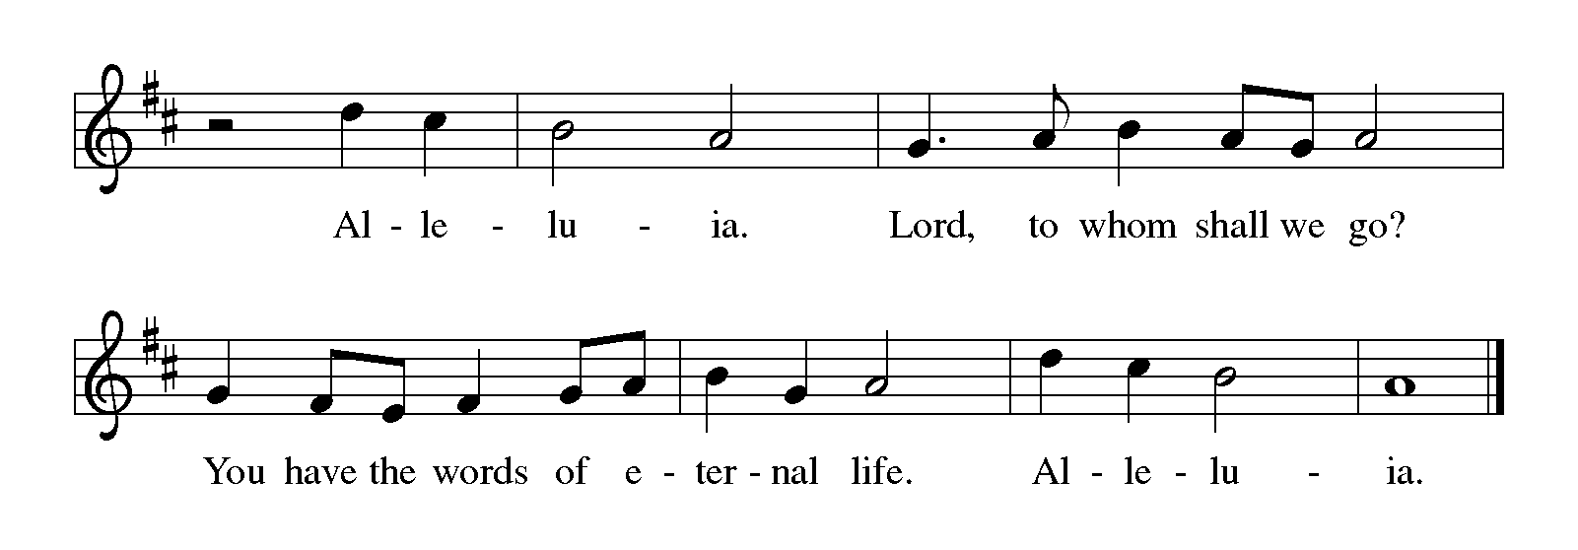P: The Holy Gospel according to St. Matthew, the fifth chapter.
C: Glory to you, O Lord.

Gospel Reading Matthew 5:1-12
When Jesus saw the crowds, he went up the mountain; and after he sat down, his disciples came to him. ²Then he began to speak, and taught them, saying: ³“Blessed are the poor in spirit, for theirs is the kingdom of heaven. ⁴“Blessed are those who mourn, for they will be comforted. ⁵“Blessed are the meek, for they will inherit the earth. ⁶“Blessed are those who hunger and thirst for righteousness, for they will be filled. ⁷“Blessed are the merciful, for they will receive mercy. ⁸“Blessed are the pure in heart, for they will see God. ⁹“Blessed are the peacemakers, for they will be called children of God. ¹⁰“Blessed are those who are persecuted for righteousness’ sake, for theirs is the kingdom of heaven. ¹¹“Blessed are you when people revile you and persecute you and utter all kinds of evil against you falsely on my account. ¹²Rejoice and be glad, for your reward is great in heaven, for in the same way they persecuted the prophets who were before you.”

P: The Gospel of the Lord.
C: Praise to you, O Christ!
Sit
Children’s Message Pam Ensley
Message Pr. Chris Hogstad
Hymn of the Day “Will You Let Me Be Your Servant” Number 659
1 Will you let me be your servant, let me be as Christ to you?
Pray that I may have the grace to let you be my servant, too.
2 We are pilgrims on a journey, we are trav'lers on the road;
we are here to help each other walk the mile and bear the load.
3 I will hold the Christ-light for you in the nighttime of your fear;
I will hold my hand out to you, speak the peace you long to hear.
4 I will weep when you are weeping; when you laugh I'll laugh with you. I will share your joy and sorrow till we've seen this journey
through.
Apostles’ Creed
I believe in God, the Father almighty, creator of heaven and
earth.
I believe in Jesus Christ, God’s only Son, our Lord, who was
conceived by the Holy Spirit, born of the virgin Mary, suffered
under Pontius Pilate, was crucified, died, and was buried; he
descended to the dead. On the third day he rose again; he
ascended into heaven, he is seated at the right hand of the
Father, and he will come to judge the living and the dead.
I believe in the Holy Spirit, the holy catholic church, the
communion of saints, the forgiveness of sins, the resurrection of
the body, and the life everlasting. Amen.
The Prayers
Called together to follow Jesus, we pray for the church, the world, and all in need.
A brief silence
Cultivate humility in your church. In gatherings of every size, teach us to boast only in the cross. Shape your church to be people of
kindness, generosity, and justice. Merciful God, receive our prayer.
The foundations of the earth bear witness to your faithfulness; the
mountains and hills echo with your holiness. When we mistreat your
-6-
-8-
creation, show us the error of our ways. Inspire us with reverent awe
to honor all you have made. Merciful God, receive our prayer.
You make foolish the wisdom of the world. Raise up honorable
leaders who seek justice, love mercy, and pursue peace. Frustrate
plans that are corrupt, wicked, and self-seeking. Prosper the work of
peacemakers. Merciful God, receive our prayer.
Bless all whom the world rejects. Accompany those who are regarded
as foolish, weak, low, and despised; reveal your power and presence
at work where it is least expected. Give your life, strength, and
wisdom to all in need, especially those we remember aloud or in our
hearts. Merciful God, receive our prayer.
As with your people Israel, remind this congregation of your saving
acts. Remind us how your faithfulness brought us through difficulties
and sustained us despite our weaknesses. Establish the cross as the
center of our life together. Merciful God, receive our prayer.
Praise to you for your blessed saints in every time and place. Trusting
you accompanied them in poverty, persecution, and in every trial, we
trust you abide with your people always. Merciful God, receive our
prayer.
We bring to you our needs and hopes, O God, trusting your wisdom
and power revealed in Christ crucified. Amen.
Peace
P: The peace of the Risen Christ be with you always. And also with
you.
Offering of Tithes and Gifts
Offertory “Do Not I Love Thee”
Philip Doddridge, setting by David W. Music
Prayer of Preparation
P: Liberating God,
C: you break the bonds of injustice and let the oppressed go free.
Receive these offerings in thanksgiving for all your works of
merciful power, and shape us as people of your justice and
freedom. You we magnify and adore, through Jesus our Savior.
Amen.
MEAL
Great Thanksgiving Page 152
Preface

Holy, Holy, Holy Page 152

Eucharistic Prayer

-8-
The Lord’s Prayer
Our Father, who art in heaven, hallowed be thy name, thy kingdom come, thy will be done, on earth as it is in heaven. Give us this day our daily bread; and forgive us our trespasses, as we forgive those who trespass against us; and lead us not into temptation, but deliver
us from evil. For thine is the kingdom, and the power, and the glory,
forever and ever. Amen.
Invitation to Communion
P: Come and taste the joy of God!
Distribution Hymns
“Come, Let us Eat" Number 491
1. Come, let us eat, for now the feast is spread, come, let us eat, for
now the feast is spread, Our Lord’s body let us take together, our
Lord’s body let us take together.
2. Come, let us drink, for now the wine is poured, come, let us drink,
for now the wine is poured; Jesus’ blood poured let us drink
together, Jesus’ blood poured let us drink together.
3. In...his presence now we meet and rest, in...his presence now we
meet and rest. In the presence of our Lord we gather, in the
presence of our Lord we gather.
4. Rise, then, to spread abroad God’s mighty Word; rise, then, to
spread abroad God’s mighty Word. Jesus risen will bring in the
Kingdom, Jesus risen will bring in the Kingdom.
“Come, Ye Disconsolate” Number 607
1 Come, ye disconsolate, where'er ye languish; come to the mercy-
seat, fervently kneel. Here bring your wounded hearts, here tell
your anguish; earth has no sorrow that heav'n cannot heal.
2 Joy of the desolate, light of the straying, hope of the penitent,
fadeless and pure; here speaks the Comforter, tenderly saying,
"Earth has no sorrow that heav'n cannot cure."
3 Here see the Bread of life; see waters flowing forth from the
throne of God, pure from above. Come to the feast of love; come,
ever knowing earth has no sorrow but heav'n can remove.
Blessing
P: May the grace of our Lord Jesus Christ and the gifts of his body
and blood strengthen, keep and unite us both now and forever.
Amen.

Prayer after Communion
Holy One, we thank you for the healing that springs forth abundantly
from this table. Renew our strength to do justice, love kindness, and
journey humbly with you. Amen.
Benediction
P: The God who faithfully brings forth justice and breaks the
oppressor’s rod ☩ bless, strengthen, and uphold you, today
and always. Amen.
Sending Hymn “Praise the One Who Breaks the Darkness” Number 843
1 Praise the One who breaks the darkness with a liberating light;
praise the One who frees the pris'ners, turning blindness into
sight. Praise the One who preached the gospel, healing ev'ry
dread disease, calming storms and feeding thousands with the
very bread of peace.
2 Praise the One who blessed the children with a strong yet gentle
word; praise the One who drove out demons with a piercing, two-
edged sword. Praise the One who brings cool water to the
desert's burning sand; from this well comes living water
quenching thirst in ev'ry land.
3 Praise the one true love incarnate: Christ, who suffered in our
place; Jesus died and rose for many that we may know God by
grace. Let us sing for joy and gladness, seeing what our God has
done. Praise the one redeeming glory; praise the One who makes
us one.

Dismissal

P: Go in peace. Follow the way of Jesus. Thanks be to God!
Postlude

Coffee Hour – Taylor Hogstad
-10-
SERVICE
Usher Norm Bembenek
Lector Pat Hagensen
Sound Tech Jorja Ladage
Digital Media Coordinator Angelyka Cava
Musicians Pat Hagensen, Gary Ritter, Judy Swanson
Lay Assistant, Basket Assistant Pam Ensley, Taylor Hogstad
Altar Guild Rae Gessford, Carol Phillips

Liturgy used with permission under license from Augsburg Fortress
through Sundays and Seasons,#SAS006227; Text, Music, and
Streaming - One License #A-706949; CCLI #791428

“Gather Us In”
Text: Marty Haugen
Music: GATHER US IN, Marty Haugen
Text and music @1982 GIA Publications Inc.; OneLicense #00031

“Will You Let Me Be Your Servant”
Text: Richard Gillard
Music: THE SERVANT SONG Richard Gillard; arr. Betty Pulkingham;
CCLI #72673; Text and Music @1979 Scripture in Song c/o Integrity’s
Hosanna Music, c/o Integrity Media, Inc.

“Do Not I Love Thee”
Text: Philip Doddridge
Music: DETROIT; The Sacred Harp; setting by David W. Music
@1988 by Concordia Publishing House

“Come, Let us Eat"
Text: Billema Kwillia, st. 1-3; Gilbert E. Doan Jr., st.4;
tr. Margaret D. Miller, st. 1-3; Music: Billema Kwillia, adapt.
Text sts. 1-3 and tune @ Lutheran World Federation; text st. 4 and
adapt. @1972 Contemporary Worship 4, admin. Augsburg Fortress

“Come, Ye Disconsolate”
Text: Thomas Moore, sts. 1-2; Thomas Hastings, st. 3
Music: CONSOLATOR, Samuel Webbe Sr.

“Praise the One Who Breaks the Darkness”
Text: Rusty Edwards
Music: NETTLETON, J. Wyeth, Repository of Sacred Music, Part II
Text @1987 Hope Publishing Co.

